Analysis of Fel d 1 Allergen Transcripts in Felis catus Saliva Using Reverse Transcription quantitative Polymerase Chain Reaction (RT-qPCR)

Savannah Tobin
February 24, 2013

Introduction:
Cats (Felis catus) are not exotic animals, yet over 600 million live in the company of humans worldwide (Beaver, 2003). Although the domestic cat has lived among us since 7500 B.C., many are allergic to the tiny protein it secretes in its salivary and sebaceous glands. This protein, Felis Domesticus 1 (Fel d 1), causes 40% of asthmatics to react to cats and in turn approximately 15% of the world’s population is deemed allergic to cats. While it’s a common misconception that cat fur is responsible for inducing allergic response, the protein Fel d 1 originates in cat saliva, and as cats groom themselves they coat their fur in the allergenic protein. And while so many suffer from cat allergies, 1/3 of the affected population is believed to keep cats as pets regardless of their allergic condition (Cat World, 2002). Although the purpose of Fel d 1 within the cat’s body is unknown, it is clear that the protein is the major allergen responsible for cat allergies. And although all cats produce Fel d 1, specific cat breeds such as the Russian Blue and Siberian have been known to produce a significantly lower level of the allergenic protein and are therefore anecdotally hypoallergenic. While little scientific evidence backs the claim of these hypoallergenic cats, those with allergies have noticed lower allergic reactivity when exposed to anecdotally hypoallergenic cats. As each individual cat produces its own unique level or rate of this protein, it is plausible that certain cats might cause allergic reactions more infrequently and with less severity. A significant portion of our global population suffers the effects of cat allergies, but if a methodology was developed to quantify this allergenic protein, more people could adopt cats less likely to cause allergic reactions and the validity of hypoallergenic cats could be tested.
Reverse Transcription quantitative Polymerase Chain Reaction (RT-qPCR) has proven to be an effective method in quantifying mRNA transcripts. This method uses an mRNA template (usually harvested from organs or in plant matter) and results in the amplification of specific cDNA synthesized in qPCR using specific primers. RT-qPCR effectively quantifies the expression of mRNA transcripts and in doing so indicates the quantity of the protein of interest. Faster and more cost effective than standard ELISA (Enzyme-linked immunosorbent assay) technology, some studies show RT-qPCR to be a more accurate and sensitive methodology when analyzing proteins (Vandenbussche, 2007). RT-qPCR of salivary mRNA is a budding field of diagnostics that has only been pursued by the lab of Dr. D.T.W. Wong of UCLA Dentistry (Wong, 2011). Dr. Wong has pursued salivary RT-qPCR to detect precancerous enzymes in human saliva. However, RT-qPCR has yet to be applied in feline saliva or in any other facet of veterinary medicine.
The purpose of this research is to utilize salivary RT-qPCR in cats for the first time in order to detect and quantify Fel d 1. Saliva samples from domestic cats will be analyzed and a new diagnostic methodology to measure Fel d 1 will be created for future veterinary medicine applications. As an allergy sufferer and owner of the anecdotally hypoallergenic Russian Blue, I will attempt to develop a new diagnostic method that can determine Fel d 1 mRNA levels in individual cats and test the validity of the hypoallergenic cat. Hypoallergenic cats are hypothesized to produce significantly lower Fel d 1 levels, and male cats are expected to produce the highest levels of Fel d 1. Male cats should produce the highest levels of this allergenic protein because testosterone is one of the known factors to regulate the production of Fel d 1 within the cat’s body.
If Fel d 1 is successfully measured in feline saliva, cats can be distinguished by their unique level of production and in turn people can adopt cats that won’t induce a significant allergic response. Allergies to cats are the primary reason for cat abandonment to animal shelters, but if the allergen can be identified in individual cats, asthmatics and allergy suffers could adopt cats they never previously imagined in their lives. In addition, a new diagnostic tool could be utilized in veterinary medicine and a non-invasive saliva assay could replace blood based diagnostics.

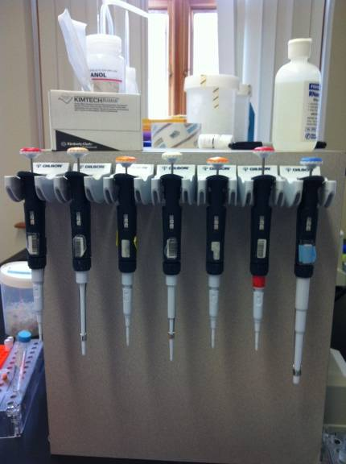
Materials:
- Applied Biosystems Step One Plus RT PCR system
- Bio Rad Model 16k microcentrifuge
- Bio Rad BR 2000 vortexer
- Bio Rad MJ Mini Personal Thermocycler
- Nanodrop spectrometer
- Gilson micropipets and tips (2µ-1,000µ)
- Microcentrifuge tubes (200µ-1.7mL)
- Puritan sterile buccal swabs with transport tube
- Cat saliva
- RT-qPCR reagents and enzymes
- Specific Primers (Fel d 1-2, Feline GAPDH, and Feline RPS7)
- -20º C freezer
- Personal protective equipment

Methodology:
Test Subjects:
Three cats were tested: a female Ocicat, a male American Shorthair, and a female Russian Blue. The Russian Blue serves as the hypoallergenic test subject to be compared to the other cats. All cats were altered. In future research, up to twenty cats will be tested.
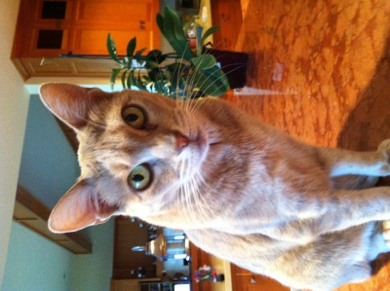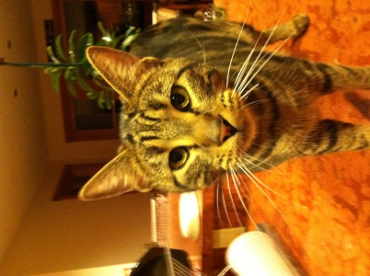
Juliette: Female 10 Saphira: Female 3 Bahgeera:Male 1
Saphira is the anectdotally hypoallergenic Russian Blue cat.

Salivary Collection and Buccal Swab Processing:
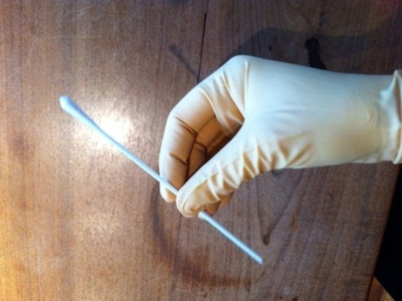
Saliva was obtained from adult cats using an RNase free technique with sterile gloves. Cats were gently wrapped in blankets, containing their bodies while exposing their heads. A sterile buccal swab was inserted into the cat’s mouth and gently brushed against each of the cat’s four cheek pouches in a circular motion. The buccal swab was then inserted under the tongue, contacting all salivary glands possible. The buccal swab was then inserted into an RNase free 1.7 mL microcentrifuge tube and cut at the base of the cotton tip with scissors sterilized with ethanol. The tube containing the swab was then labeled with the cat’s name as well as the date and time of extraction. Studies show that saliva has natural stabilizing enzymes that keep mRNA intact for up to three months at room temperature, but samples were refrigerated to inhibit the growth of bacteria until transported to the lab (Wong, 2011). In order to acquire a large enough sample, each cat was swabbed three times to obtain a sufficient starting volume of saliva. The swabbing process is the extent of cat participation in this research, and the process itself takes under a minute.
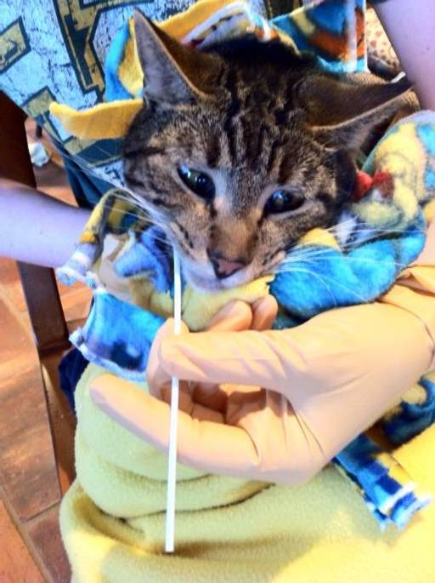
Cat being swabbed Sterile buccal swab

A new technique was developed to pool buccal swabs resulting in feline whole saliva. At the BSL 1 lab (Willamette University) the swabs were centrifuged at 8,000xg for one minute and then carefully inverted with two sets of sterile tweezers and replaced in the microcentrifuge tubes. The tweezers were sterilized with 70% ethanol between inversions among samples of different test subjects. Once the swabs were inverted, the samples were centrifuged again at 8,000xg for an additional minute to pull remaining saliva out of the cotton swab. The swabs were then discarded in an autoclave, and the supernatant in the microcentrifuge tube was centrifuged briefly to condense a pellet. At this point, there were three microcentrifuge tubes containing pure saliva for each of the cats being tested. The samples were then pooled by pipetting an individual’s saliva into a single microcentrifuge tube. The pooled sample was then vortexed and centrifuged briefly three times. Anywhere from 30 µl to 200µl of feline whole saliva was collected depending on the cat’s mouth size and varying production of saliva. Empty microcentrifuge tubes were then discarded in an autoclave and the samples were set on ice until experimentation progressed.
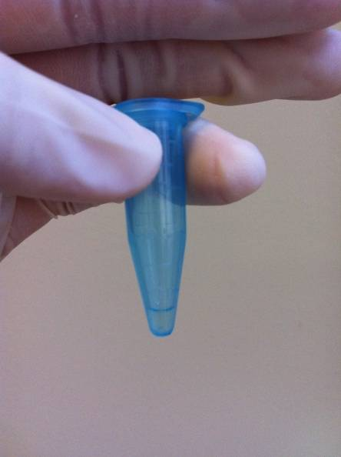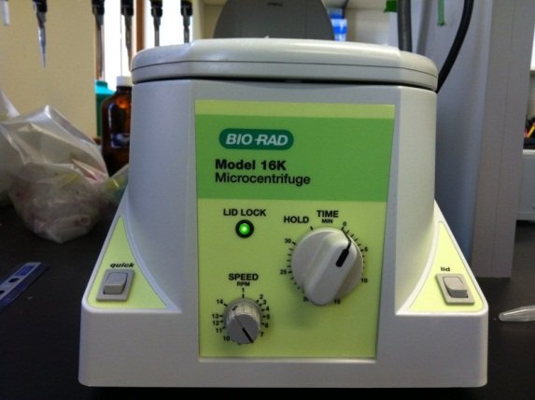
Pure feline saliva post swab processing Microcentrifuge

Nanodrop Spectrometer:
A Nanodrop 1000 was used to preliminarily quantify the mRNA content of saliva samples. To test a sample, the pedestal was loaded with 2µl Rnase free water followed by 2µl of sample. At the start of this research, no mRNA could be found in saliva samples due to the purification process known as extraction. Essentially, the mRNA within the sample was being diluted in an attempt to purify the sample (eliminating gDNA and bacteria). After two months of experimentation, pure feline whole saliva was tested on the Nanodrop without going through extraction and mRNA was found. It was later discovered that the process of extraction on saliva dilutes the mRNA content by over 200 times, and if extraction was to be pursued, a larger sample volume was required. After it was discovered that whole saliva contained anywhere from 300 ng/µl- 700 ng/µl of mRNA, the research progressed to RT-qPCR. Samples were not tested on the Nanodrop on every trial as the purpose of the device was to determine whether mRNA existed in the samples. After mRNA content was established the Nanodrop was not used again. There were no previous studies indicating the possibility of mRNA detection in feline salivary samples. This is the first study to verify the existence of mRNA in cat saliva.

Primer Design:
Since this study documents the first feline salivary RT-qPCR assay, primers were designed and tried throughout experimentation. A primer is a short section of a genetic sequence that codes for a specific gene and is used during qPCR. In this case, Fel d 1, GAPDH (Glyceraldehyde 3-phosphate dehydrogenase), and RPS7 (ribosomal protein S7) genes were pursued and primers were created for each gene. Fel d 1 is the allergenic protein in cat saliva, GAPDH is a protein that processes glucose, and RPS7 is a ribosomal protein that aids in the creation of new protein production. GAPDH was used as the original endogenous control, but for further optimization, RPS7 was pursued as GAPDH primers tended to produce imperfect melt curves. Originally, the GAPDH primer was taken from a published paper utilizing RT-qPCR with feline organ samples (Kessler, 2009). One of the two RPS7 primers tested was also utilized from this paper. After imperfections occurred using the published GAPDH primer, a new GAPDH primer was designed with a lower GC content (55%), an optimal melting temperature, and an optimal product length. In regards to Fel d 1, primers for both chains of the protein Fel d 1 chain 1 and Fel d 1 chain 2 were created and tested side by side. Fel d 1 chain 2 (Fel d 1-2) proved to amplify more cleanly and accurately so it was used for the duration of this study. As mentioned previously, RPS7 primers were then designed to further optimize the study. The first RPS7 primer came from the Kessler paper and the second was designed specifically for this research. Both were tested side by side and both amplified cleanly and produced a single melt curve product. The published RPS7 primer was discarded as a mistake was made in the design of this primer. The RPS7 primer I designed was used for all following experimentation.
All primers were created using NCBI and IDT (Integrated DNA Technologies) online databases and services. The primers pursued in this research proved to be acceptable in feline salivary diagnostics.
Gene | Forward/Reverse | Sequence | Product Size | Designer
GAPDH | forward | GCCATCAATGACCCCTTCAT | 82 | (Kessler,2009)
GAPDH | reverse | GCCGTGGAATTTGCCGT | 82 | (Kessler.2009)
GAPDH | forward | GGCGTGAACCACGAGAAGTA | 144 | Tobin
GAPDH | reverse | GATGGCATGGACTGTGGTCA | 144 | Tobin
RPS7 | forward | GTCCCAGAAGCCGCACTTT | 74 | (Kessler,2009)
RPS7 | reverse | CACAATCTCGCTCGGGAAAA | 74 | (Kessler,2009)
RPS7 * | forward | GACGAGTTCGAGTCTGGACAT | 90 | Tobin
RPS7 * | reverse | CGTGATGTTCAGCTCCCTCA | 90 | Tobin
Fel d 1-1 | forward | AAGGATGTTAGACGCAGCCC | 89 | Tobin
Fel d 1-1 | reverse | CAACATCCCTCTTCACGGCT | 89 | Tobin
Fel d 1-2 * | forward | TTGCTACGTGGAGAACGGAC | 72 | Tobin
Fel d 1-2 * | reverse | TTGCTGGAGCTGATGGTTGT | 72 | Tobin

Above is a table of all primers tested. Red asterisks indicate chosen primers continually tested throughout experimentation for optimal results.

Reverse Transcription:
Preparation-
Immediately after the pooling of samples, preparations for reverse transcription were made. Reverse transcription is the process where mRNA within a sample is transcribed into cDNA. The resulting cDNA is then used as a template for qPCR. Throughout the procedure, an RNase free technique was used. A lab coat, goggles, and gloves were worn for the duration of the experiment and RNase-Zap was utilized to clean surfaces, pipets, and gloves throughout experimentation.
To prepare for reverse transcription, 10mM dNTP, EDTA, 10x buffer, 5x buffer, and .1 M DTT (all from Qiagen) were taken out of the -20º C freezer and set on the bench to thaw. When the reagents were fully thawed, each was vortexed, centrifuged, and put on ice. The primers for the genes of interest (Fel d 1-2, Feline GAPDH, and/or Feline RPS7) were also taken from the freezer and set to thaw. The enzymes RNase Out, Super Script III (SSIII), and Dnase Out were left in the freezer until needed.
200 µl RNase-free tubes were clearly labeled with the RNA sample ID (the cat), the target gene, my initials, negative or positive, and the date. The negative reverse transcription control tubes don’t receive the Super Script III. The utilization of gene specific primers during reverse transcription required both a negative and positive reaction for each cat. Two genes were tested, so each cat required a Feline GAPDH or RPS7 negative and positive reaction as well as a Fel d 1-2 negative and positive reaction. Essentially, each cat had four reactions per experiment.
When the primers were fully thawed, each was vortexed and centrifuged three times. Then 5 µl forward and 5 µl reverse primers were added into a 1.7 mL microcentrifuge tube labeled with the primer’s name. The primer stock was 100 MM concentration, and the inner primer solution used for reverse transcription must be 50MM. If more inner primer solution was needed for a larger sample size, 5 µl more of both forward and reverse primers were added in equal parts until desired volume was obtained. The primer stock was then returned to the freezer and the inner primers were vortexed vigorously and centrifuged three times. The primers were then set on ice.

Protocol-
The saliva samples were vortexed and centrifuged at >4,000xg three times. 12.6 µl RNase free water was then added to each 200 µl microcentrifuge tube. Then 4 µl of sample were added to the microcentrifuge tubes according to previous labels. A total starting volume of 16.6 µl was achieved for each reaction tube. Excess saliva was discarded in an autoclave and the reactions were vortexed and centrifuged >4,000xg three times.
To each reaction, 1 µl RNase Out, 1.6 µl 10x DNase buffer, and 5 µl DNase Out were added. The DNase Out was added last, and the reactions were quickly pipetted up and down to mix the reaction. A timer was then set for six minutes and the reactions were incubated at room temperature. During incubation, the thermocycler was turned on and the program “70 Hold” was selected and set for a volume of 25 µl. Immediately after six minutes, 1.2 µl 25mM EDTA was added to each reaction (to inhibit the DNase digestion) and the tube was then flicked to mix. All reactions were then centrifuged >4,000xg.
Next the samples were incubated in the thermocycler at 70º C for five minutes. After incubation the reactions were set on ice for a few minutes to cool and then centrifuged at >4,000xg to collect any condensation. The thermocylcer was then reset to “70 Hold” once more.
2 µl of inner primer were then added to each sample. Feline GAPDH or RPS7 primer was added to its specified tubes and Fel d 1-2 was added to its corresponding tubes. It’s important to match up the correct primer with its allocated labeled tubes. Then 1 µl 10mM dNTP was added to each reaction, and tubes were then vortexed and centrifuged at >4,000xg. Samples were then incubated once again in the thermocycler for five minutes. Reactions were put on ice for several minutes, and then centrifuged once more.
While the reactions incubated in the thermoclycler, a mix was made in a 1.7 mL microcentrifuge tube. The number of reactions (plus one extra for pipet error) were multiplied by 6 µl 5x RT buffer, 1 µl RNase Out, and 1 µl .1 M DTT. The mix was then vortexed and centrifuged three times. Then 8 µl of the mix was added to each reaction. Next 1 µl SSIII was added to the positive reactions only. It is very important not to add the SSIII to the negative controls so they do not become cDNA. Then 1 µl of RNase free water was added to negative reactions only to make up for the volume difference. The samples were then vortexed and centrifuged at >4,000xg and incubated in the thermocycler under the program “RT 50” (volume set for 40 µl). The reactions then incubated for about an hour. In the program “RT 50” incubation temperatures are as follows: 50º C for 50 minutes, 85º C for 5 minutes, and 4º C until samples are removed for further experimentation. The 4º C mode acts as a freezer to preserve the samples. Samples are then stored in the -20º C freezer.
The unique aspect of the modified reverse transcription developed in this study is the low sample volume required for experimentation. Only 4 µL of feline saliva is needed for analysis, whereas ELISA technology requires hundreds of microliters if not milliliters of starting sample.

quantitative Polymerase Chain Reaction (qPCR):
Preparation-
qPCR is the process where cDNA is amplified within the qPCR instrument and specific gene expression is quantified using a fluorescent dye called SYBR Green. cDNA was taken from the -20º C freezer and set on the bench top to thaw. Diluted primer mixes (10 µl forward primer, 10 µl reverse primer, 80 µl RNase free water- all vortexed and centrifuged three times) were also set on the bench top to thaw. 200 µl microcentrifuge tubes were labeled with the test subject, gene of interest, negative or positive, and the date. Two 1.7 mL tubes were labeled as “Fel d 1 mix” and “GAPDH mix” or “RPS7 mix”.
Once the cDNA completely thawed, all samples were centrifuged at >4,000xg and vortexed three times. 4 µl of cDNA were then pipetted into corresponding tubes according to labels. 36 µl of RNase free water were then added to each sample. cDNA was returned to the freezer and the samples were centrifuged at >4,000xg and vortexed three times once again.
The qPCR primer mixes were then made according to this ratio: 5 µl SYBR Green, 0.5 µl primer, and 1.5 µl Rnase free water. A primer mix was created for each gene of interest multiplying the ingredients by the number of reactions plus one extra. For example, if there were 22 reactions for Fel d 1, you would multiply each ingredient of the primer mix by 23 (including one extra portion for pipet error). Once primer mixes were made, each was centrifuged at >4,000xg and vortexed three times. The diluted primers were then returned to the freezer. It’s important to note that diluted primers are used during qPCR and primer stock is used during RT.

qPCR:
Before starting qPCR, a diagram of the qPCR plate was drawn in the lab book to map out the design of the plate. The labeled plate design was then referred to if necessary while pipetting the plate.
A 96 well qPCR plate was used for experimentation. The plate was carefully labeled with black sharpie indicating each reaction and then put on a cold block from the -20º C freezer. Each sample was tested in triplicates. To begin, 3 µl of RNase free water was pipetted into all water reactions. Each gene had two water reactions treated as a control to monitor erroneous amplification of primer dimers. Next 3 µl of the corresponding cDNA was pipetted into the well plate. It’s very important to record where each sample goes in your laboratory notebook so future amplification is properly identified. Then 7 µl of the corresponding primer mix (GAPDH primer for GAPDH reactions and Fel d 1 primer for Fel d 1 reactions) was pipetted into all wells including water reactions. Water reactions received primer mix last in case of depletion. Throughout this research, the water reactions were always kept in the bottom right corner of the plate to avoid contamination. Samples of different cats were separated by a row of wells if possible to avoid contamination as well.
The plate was then sealed and set in the qPCR instrument. qPCR analysis was run for two hours using SYBR Green as a fluorescent dye indicator. A melt curve was attached to the end of the amplification cycles to indicate product similarities. The experiment was labeled on the computer with my name and the date, and the qPCR instrument was started. Finally, the qPCR plate was labeled on the computer according to the map planned out in the lab book, and the lab was then cleaned from previous use. The entire qPCR experiment takes approximately two hours, at which point cycle times and melt temperatures are recorded and graphs are created. The cycle times and melt temperatures are then recorded in the lab book and ∆∆CT calculations are done. Amplification plots and melt curve graphs are stored on a flash drive for further use.
qPCR Plate Design qPCR Sealed 96-well Plate
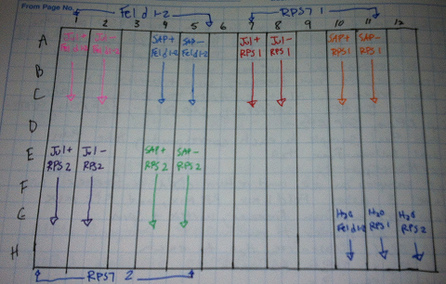
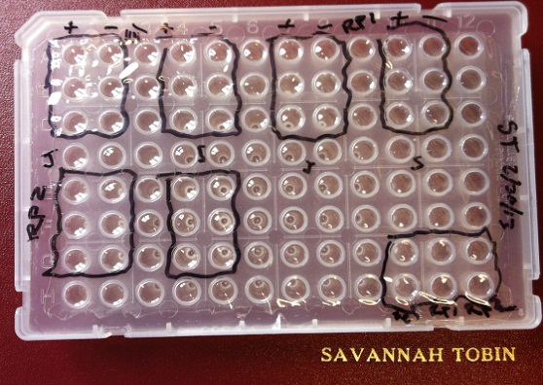

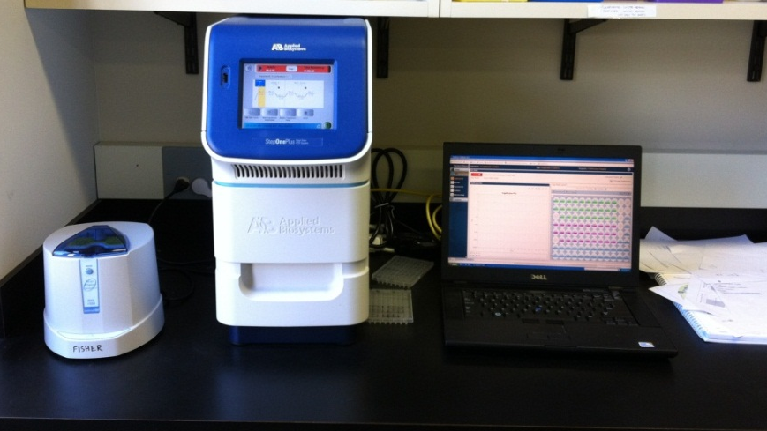
qPCR Instrument

Data Analysis- ∆∆CT Calculations:
∆∆CT calculations were used to analyze all data. As all experiments were run in triplicates and therefore produced three CT values (values that represent when amplification begins), the first step was to average and find the standard deviation for both the positive and negative CT values. This is done for both Fel d 1 (target gene) and GAPDH/RPS7 (endogenous control). Negative controls should always have higher CT values then positive CT samples as larger CT values correlate to lower levels of expression. Typically, a table was created within the lab book recording CT values along with averages and standard deviation values. This table was then referred to throughout calculations.
The next step was to normalize the amount of RNA in the reactions by subtracting the average CT value for GAPDH or RPS7 from the average CT value of Fel d 1 (1). Then the standard deviation was calculated by finding the square root of the standard deviations for Fel d 1 squared plus GAPDH or RPS7 squared (2). This was done for each cat tested. This calculation is called the ∆CT calculation as it compares or normalizes the expression of the target gene to the endogenous control gene in preparation to compare multiple cats side by side.
(1) $∆C_{T} = \overline{C_{T}}\left(Fel d 1\right)- \overline{C_{T}} (GAPDH)$
(2) $\sqrt{\sqrt{s^{2}} Fel d 1+ s^{2 }GAPDH}$

To compare the expression of Fel d 1 amongst multiple cats, a ∆∆CT equation was used (3). This was done by subtracting the “calibrator” cat’s ∆CT value from the other cat’s the ∆CT value. The calibrator was always the hypoallergenic cat test subject. The standard deviation value used in ∆∆CT was the same value used for each ∆CT value.
(3) $∆∆C_{T}= ∆C_{T\left(cat\right)}-∆C_{T(calibrator)}$

The last mathematical step was calculating the relative quantity (RQ) value (4). This calculation shows the fold difference of expression of Fel d 1 among multiple cats. A maximum and minimum RQ value was also calculated to express the error which is not proportionate due to the exponential nature of CT values.
(4) $RQ=2^{-∆∆C_{T}}$

Sample Calculation:
Cat | Fel d 1 CT | Avg. Fel d1 CT | RPS7 CT | Avg. RPS7 CT | ∆CT | ∆∆CT | RQ | RQ min | RQ max
Juliette | 26.7 | 26.73±0.62 | 24.79 | 24.63±0.24 | 2.1±0.66 | −1.2±0.66 | 2.31 | 1.5 | 3.63
 | 26.13 |  | 24.35
 | 27.37 |  | 24.75
Saphira | 27.5 | 27.35±0.51 | 23.93 | 24.05±0.10 | 3.3±0.52 | 0±0.52 | 1 | 0.7 | 1.43
 | 27.76 |  | 24.11
 | 26.78 |  | 24.1

Product Verification:
A melt curve analysis was run at the end of the amplification cycles on the qPCR instrument. Melt curves display a graphical representation of the melting temperature at which amplification occurs in the qPCR instrument. If the triplicates are aligned, only one product is being amplified. If multiple peaks appear on the graph, more than one product is being amplified or primer dimers are present (primers binding to themselves) and qPCR is unsuccessful.

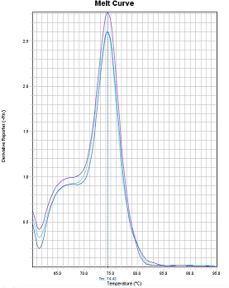
Example melt curve of Fel d 1. All triplicate peaks align indicating a single product.

A gel was also run with a ladder and the product of qPCR to see if the product size of the primer matched its intended target. The Fel d 1-2 primer used was supposed to have a product length of 72 bp, and by running a gel with a ladder, this product length was confirmed.
The beginnings of a sequencing process were started, but not completed. Essentially, products run through a gel were cut out of the gel, purified, and sent off to a lab with its forward and reverse primers to be sequenced. If the sequence in the product matches its primer sequence, Primer Blast from NCBI can be used to verify that the intended target gene is the product being amplified in qPCR. Due to the loss of samples in the mail and lack of time, sequences were not obtained but will be pursued in future research.

Results:
Fel d 1, GAPDH, and RPS7 were all successfully detected and quantified in feline saliva. Below is an example of the raw data produced from the qPCR instrument known as an amplification curve. This amplification curve represents the expression of Fel d 1 and GAPDH in a cat named Juliette. On the x-axis is the cycle time (CT) which counts the number of cycles the qPCR instrument heats and cools the double stranded helixes of cDNA before primers attach and the polymerase begins the amplification process. Larger CTs indicate lower expression levels and smaller CTs indicate higher expression levels. On the y-axis is a measurement of fluorescence. In this case, there is more Fel d 1 (represented by the blue lines) relative to GAPDH (represented by the red line). Essentially the amplification curve graphically represents when amplification begins. Each reaction is run in triplicates, so a tight amplification curve indicates a more precise experiment. ∆∆CT calculations then process the raw data represented in the amplification curves and create relative comparisons among cats.

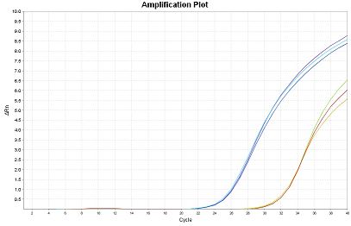
Example amplification curve of Fel d 1 and GAPDH

Seven trials were conducted, but not all yielded conclusive results. Throughout this research, different primers were utilized and discarded in an attempt to optimize the methodology. Data will be reported to elaborate on all trials, but conclusions will only be drawn from optimal experiments. As the first study to attempt feline salivary RT-qPCR, experimental changes were rapid as primers were changed and results were analyzed. By the end, a satisfactory method was successfully developed to measure Fel d 1 mRNA expression levels.

GAPDH was the first endogenous control gene tested. The first two trials supported the hypothesis that hypoallergenic cats produce significantly lower levels of Fel d 1 when compared to normal cats. In these trials a female Russian Blue (the anecdotally hypoallergenic cat) and a female Ocicat were compared. Below are graphs of the relative expression of Fel d 1 comparing the two cats. On the x-axis are the two cats, and on the y-axis is a measurement of relative expression (Fel d 1/GAPDH). GAPDH is the control gene that normalizes the data, and the y-axis simply represents a relative measure of Fel d 1 expression between the two cats being tested.

Saphira is the hypoallergenic cat and Juliette is the normal cat. The first trial indicates that Juliette expressed 236 fold the amount of Fel d 1 as Saphira. The second trial shows that Juliette expressed 3 fold the amount of Fel d 1 as Saphira. Although both trials support the hypothesis that hypoallergenic cats produce less Fel d 1, the difference of relative expression between trials indicates that Fel d 1 levels fluctuate in feline saliva. Both trials utilized GAPDH as a control gene, and as the first successful representations of amplification of both Fel d 1 and GAPDH in feline saliva, these trials do not represent optimal functionality of the methodology developed in this research.

The third trial included a male test subject (Bahgeera), and this trial supports the hypothesis that males produce the most Fel d 1. This trial utilized the same primers as the first two, however, the normal female Juliette actually expressed less Fel d 1 then the hypoallergenic cat Saphira.

There are a variety of possibilities that could account for Juliette’s lower expression of Fel d 1. Because the levels of Fel d 1 fluctuate in feline saliva, Juliette could have simply produced less Fel d 1 then Saphira, or the food or water she consumed could have affected the results. Since the purpose of Fel d 1 is unknown, any number of bodily functions and processes could alter the expression of this protein. Because of these results, the melt curves which indicate product verification were looked at more closely. Upon review, it was found that the GAPDH primer used created an imperfect melt curve indicating the possibility of multiple products being amplified. Not all reactions displayed the possibility of multiple products being amplified, but upon these results, new primers were designed to optimize the accuracy and effectiveness of this methodology.

New GAPDH primers were created and tested on the same three cats, and although the new primers indicated a single product by melt curve analysis, the negative reactions amplified before the positive reactions in Juliette’s samples. Positive reactions are those which contain the cDNA template required for qPCR amplification. Negative reactions do not receive SuperScript III which transcribes mRNA into cDNA, and therefore, the negative reactions act as a control that should show no significant amplification. Because Juliette’s negative reactions amplified before her positive reactions, the experiment and GAPDH primer was discarded.

In an effort to further optimize the methodology, the GAPDH gene was discarded altogether and the ribosomal protein RPS7 was pursued. RPS7 is the endogenous regulator gene of choice when working with feline tissue-based RT-qPCR (Kessler, 2009). Published RPS7 primers were tested along with another RPS7 primer that was specifically designed for this study (Kessler, 2009). Both RPS7 primers amplified cleanly and indicated a single product in melt curve analysis. However, upon further review, it was discovered that the published primer was designed imperfectly and the data was rendered invalid. While ordering the published primer, the forward primer was the correct RPS7 gene, but the reverse primer was copied incorrectly from the gene HPRT. It is unclear why the erroneous primer amplified at all, but the RPS7 primer designed specifically for this research became the endogenous control of choice. The results of this experiment indicate lower levels of Fel d 1 in the hypoallergenic cat Saphira. Juliette expressed 2.3 fold the Fel d 1 as Saphira. This experiment represents optimal results.

RPS7 endogenous control experiment-optimal results

The RPS7 primer was chosen for further experimentation because it produced a single melt curve product and its negative controls amplified around 10 cycle times later then the positives samples. This indicated that the negative reactions were not producing the same product as the positive reactions. The insignificant amount of amplification shown by the negative reactions is probably due to primer dimers-where a primer begins to bind to itself. Below is a table noting the difference in cycle times (CT) between the positive and negative reactions in this experiment.

Fel d 1 RPS7
+CT | -CT
23.93 | 34.5
24.11 | 34.55
24.1 | 33.73
24.05 | 34.26
+CT | -CT
23.93 | 34.5
24.11 | 34.55
24.1 | 33.73
24.05 | 34.26

Example Saphira CT values show the insignificant amplification of –CTs.

Discussion:
While Fel d 1 was successfully detected in feline saliva, Fel d 1 levels fluctuated from sample to sample. A diagnostic method was successfully developed to quantify Fel d 1 mRNA transcripts in feline saliva and the diagnostic method was then optimized by trialing several primers. The data collected supports the claim that hypoallergenic cats produce lower levels of Fel d 1, but further research must be conducted to positively confirm this claim.

There are several possible sources of error in this research. The largest error (the unreliable endogenous control primer GAPDH) was addressed and the technique was further optimized using the more dependable RPS7 protein as an endogenous control. Here are examples of both the GAPDH and RPS7 melt curves. While the GAPDH displayed a misshapen curve, RPS7 represents a single product which effectively eliminates this error. Because GAPDH was an imperfect control, the results produced from this primer are less significant, but the trialing of endogenous control primers was a valid and necessary part of this experimentation. Other errors include pipet error and possible contamination of samples.
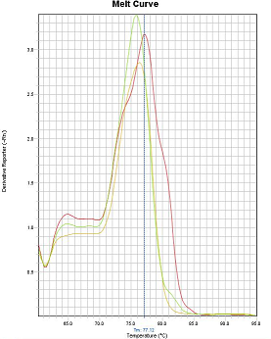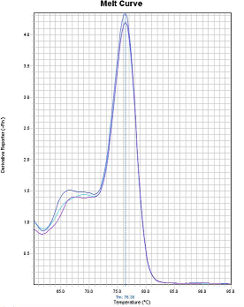
GAPDH melt curve RPS7 melt curve

While utilizing GAPDH as a control gene, data varied significantly between trials. This is to be expected as the quality of the GAPDH primer was inadequate. The optimal RPS7 primer is still in the preliminary stages of testing so it is not yet known if results vary among separate trials. As previously stated, uncontrollable factors such as the possible fluctuation of Fel d 1 in feline saliva, the effect of food and water on expression level, and many other internal bodily processes could account for variations in the results. While variations in results occurred the main objective of this research was achieved by developing a methodology that can detect Fel d 1 in feline saliva.
As an ongoing investigation, data is still being gathered and future goals are yet to be achieved. Now that an optimized methodology has been created, the sample size will be increased. I aim to test around twenty cats of both genders to increase and further validate data already collected. If possible, other Russian Blue cats will be tested to extend the hypoallergenic specimen sample. In addition to increasing the sample size, further product verification should be conducted to yield conclusive results. Sequencing of both Fel d 1 and RPS7 qPCR products will be pursued in order to further optimize the methodology of this research. If possible, the methodology developed in this research should be compared to standard methods such as ELISA technology. By comparing the two methodologies side by side, the technique developed in this research can become a valid diagnostic test. While this research is still premature in assuming definite conclusions, the objective was achieved by successfully detecting Fel d 1 in cat saliva and by developing a diagnostic methodology that can be used for future experimentation. All that remains is the replication of experimentation to further this research.

Conclusion:
A new diagnostic method was developed to successfully detect and quantify Fel d 1 allergen transcripts in feline saliva. Non-invasive, more cost efficient, and faster than standard ELISA technology, the feline salivary RT-qPCR documented in this research is the first of its kind. The methodology developed in this research was optimized by trialing a series of primers and different control genes. While further replication is needed to positively confirm conclusions, current data supports the hypothesis and claim that hypoallergenic cats produce less Fel d 1 then average cats. The main objective of this study was achieved in the development of a feasible and cost effective way to measure Fel d 1, and what remains is mass replication and generation of data.
The methodology developed in this research can be used in future veterinary diagnostics as a tool to measure allergen transcripts of all animals and replace blood based diagnostics. This methodology can be used to test cats for individual production levels of Fel d 1 and help connect people with animals that won’t cause allergic reactions with such severity.

Acknowledgements:
I have had several mentors on this scientific journey, but I’d like to thank first and foremost Jonathan Williams and Dr. Alison Fisher. Without Mr. Williams, none of this would be possible as he connected me with Prof. Fisher. His constant guidance has helped me to achieve more than I ever thought to be possible. I’d like to thank Dr. Fisher for opening her lab facilities to my research and aiding in the intellectual development of this project. Without her time and laboratory, my project would not exist. I’d also like to thank Geri Laudenbach for teaching me the art of RT-qPCR and for the patience she showed as I learned the ways of the pipet. My science teachers Mr. Michael Lampert and Mr. Steven Holman also deserve thanks for guiding me and challenging my intellectual horizons. I’d like to thank Life Technologies for donating the reagent SYBR Green to my student project and SSP for help funding my research in part. Dr. Wong and Dr. Lau of UCLA School of Dentistry also deserve my thanks for setting me on the right path and showing patience with a high school student. Their work in salivary diagnostics inspired me to pursue my research and the running dialogue I had with Dr. Lau kept me on track. And finally I’d like to thank my family for always supporting and encouraging me and all of the cats who participated in this project. Without my cats none of this would be possible, from the inspiration they provided to the samples they produced, they have changed my life forever.

References:
B. Thornton, C. Basu. 2010. Real-time PCR (qPCR) primer design using free online software. Bmb 39:145-
154.
Bonnie Beaver (2003) Feline Behavior; A Guide for Veterinarians.
Cat Allergen [Internet]. Auckland Allergy Clinic; [cited 2012 Nov. 15]. Available from:
http://www.allergyclinic.co.nz/guides/7.html
Eickelberg G, Fisher A. Environmental regulation of plant gene expression: a “real=time” quantitative
PCR laboratory project for an upper-level undergraduate biochemistry or molecular biology course.
for submission to Biochemical and Molecular Biology Education.
J. Winer, C.K.S. Jung, I. Shackel, P.M. Williams. 1999. Development and validation of real-time
quantitative reverse trancriptase-polymerase chain reaction for monitoring gene expression in
cardiac myocytes in vitro. Abio 270:41-49.
K.J. Livak, T.D. Schmittgen. Analysis of relative gene expression data using real-time quantitative PCR and
the 2−∆∆CT method. Applied Biosystems [Internet]. 2001 [cited 2012 June 6]; 25:402-408. Available
from: doi:10.1006/meth.2001.1262.
M.A. Gomes-Keller, E. Gonczi, R. Tandon, F. Riondato, R. Hofmann-Lehmann, M.L. Meli, H. Lutz. 2005.
Detection of feline leukemia virus RNA in saliva from naturally infected cats and correlation of PCR
results with those of current diagnostic methods. J Clinc MB. 2006.
Marsh T. [Internet]. Hypoallergenic cats- do they exist?; [cited 2012 Nov. 15]. Available from:
NCBI [Internet]. National Center for Biotechnology Information; [cited 2012 June]. Available from:
http://www.cat-world.com.au/hypoallergenic-cats-do-they-exist http://www.ncbi.nlm.nih.gov/
Nature Publishing Group. 2005. Prime time for real-time PCR. Nature Methods 2:305-312.
PCR Primer Design [Internet]. Molecular Biology Today; 2(2): 27-32 [cited 2012 July 15]. Available from:
http://www.horizonpress.com/mbt/v/v2/v2n2/03/frame3.html
Qiagen [Internet]. Sample and assay technologies; [cited 2012 June 16]. Available from:
http://www.qiagen.com/
Testing Fel d1 Allergen [Internet]. Kitten Testing; [cited 2012 Nov. 15]. Available from:
http://www.kittentesting.com
Turner and Bateson (2000) The Domestic Cat; The biology of its behavior.
Vandenbussche F., Vanbinst T., Verheyden B., Van Dessel W., Demeestere L., Houdart P., Bertels G.,
Praet N. Berkvens D., Mintiens K, Goris N., De Clercq K. Evaluation of antibody-ELISA and real-time RT-
PCR for the diagnosis and profiling of bluetongue virus serotype 8 during the epidemic in Belgium in
2006. [Internet] 2007. cited July 2012; 129:15-27. Available from:
http://dx.doi.org/10.1016/j.vetmic.2007.10.029.
Y. Kessler, A.K. Helfer-Hungerbuehler, V. Cattori, M.L. Meli, B. Zellweger, P. Ossent, B. Riond, C.E.
Reusch, H. Lutz, R. Hofmann-Lehmann. 2009. Quantitative TaqMan real-time PCR assays for gene
expression normalization in feline tissues. BMC 10:106.
Y. Lee, H. Zhou, J.K. Reiss, X. Yan, L. Zhang, D. Chi, D.T.W. Wong. 2011. Direct saliva transcriptome
analysis. Clin Chem 57(9):1295-1302.
Y. Li, X. Zhou, M.A.R. St. John, D. T. W. Wong. 2004. RNA profiling of cell-free saliva using microarray
technology. J Dent Res 83:199-203.

